**Assignment: Ninja Gold Game**

Create a mini-game that helps a ninja make some money! When you start the game, your ninja should have 0 gold. The ninja can go to different places, farm, cave, house, casino, and earn different amounts of gold. In the case of the casino, your ninja can earn or LOSE up to 50 golds. Your job is to create a web app that allows this ninja to earn gold and to display past activities of this ninja.

You should only need 2 methods to complete this task. Hint: Use hidden inputs to differentiate the forms.

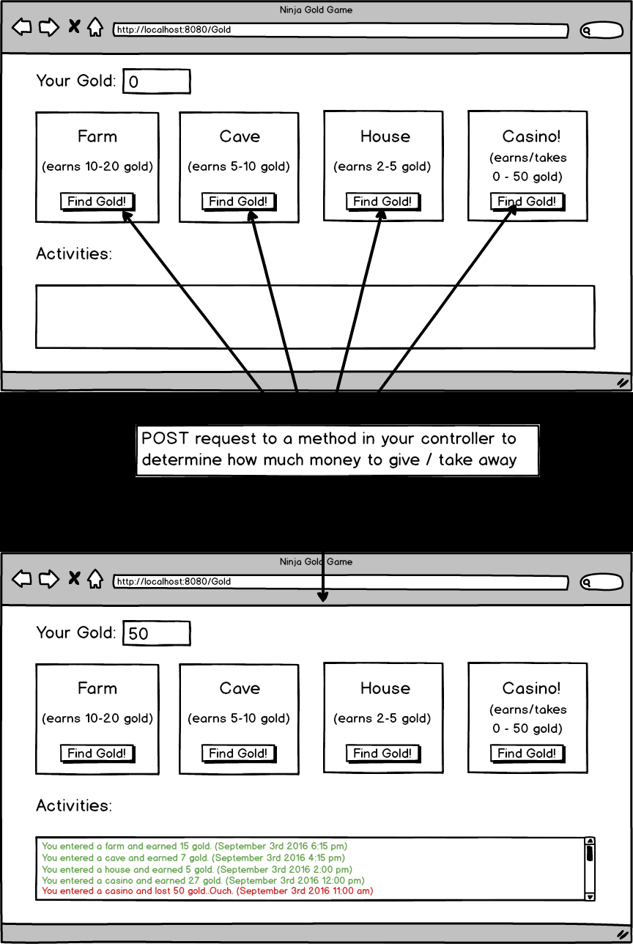

Topics:

* POST
* Redirects

Tasks:

* Start with 0 gold.
* Have 4 separate forms making POST requests
* farm - add 10 - 20 to gold
* cave - add 5-10 to gold
* house - add 2-5 to gold
* casino - add or remove 0-50 to gold
* Keep a log including the timestamp for each submission.
* Use only two methods

Optional Challenges:

* Create a fifth place "spa" where the ninja loses 5-20 gold (10-45 minutes)
* Create a reset button (5-30 minutes)